Fundamental of Psychology
Myths about Psychology
- It’s all about reading faces and judging people
- Psychologist are magicians that can read mind and faces
- Psychiatrists are crazy people too
- Visiting psychiatrist means you are abnormal
What is Psychology:
- Derived from two Greek words
- Psyche means soul
- logos means to talk.
- literal meaning of Psychology is: to talk about soul.
Definition
Psychology is a science which deals with the behavior and minds of animals and human beings, both
Or branch of science focuses on two things
- Cognition (Mental Process)
- Not Solely related to abnormality (psychology is about understanding the human mind and behavior as a whole, not just focusing on mental illnesses)
Facts about Psychology:
- Psychology is a structured field of knowledge.
- It gathers and studies information.
- Psychologists help people live a balanced life.
- Anyone can see a psychologist, from simple counseling to treating major disorders
Behavior and Mind
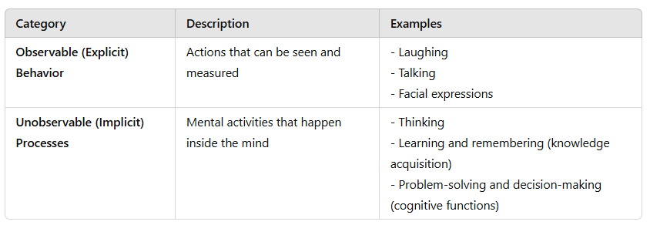
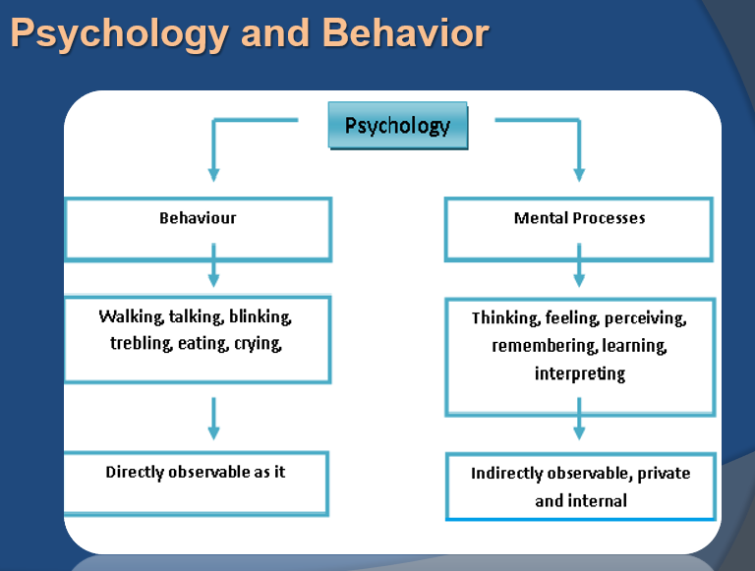

Understanding Behavior
Behavior refers to how people interact with others or themselves. Examples include:
- Talking to a friend
- Smiling when happy

Influence of Culture on Behavior
Culture plays a big role in shaping behavior. People from different cultures may express emotions in unique ways.
Example:
- In Western cultures, maintaining eye contact while talking shows confidence and respect.
- In some Asian cultures, avoiding eye contact can be a sign of respect, especially when speaking to elders.
Factors:
1. Literacy Rate & Living Standards
- A person’s education level and quality of life affect their behavior and communication.
- Higher literacy rates often lead to better decision-making and social interactions.
2. Social Interaction
- The way people connect and communicate with each other is shaped by their cultural background.
- Some cultures encourage open discussions, while others emphasize politeness and indirect communication.
3. Personal Space
- Cultural norms define personal space, which affects interactions.
- Example: In some cultures, maintaining a certain distance while talking is essential for respect, while in others, standing close shows warmth and friendliness.
4. Culture Shapes Behavior
- Culture influences personal growth, opportunities, and individuality.
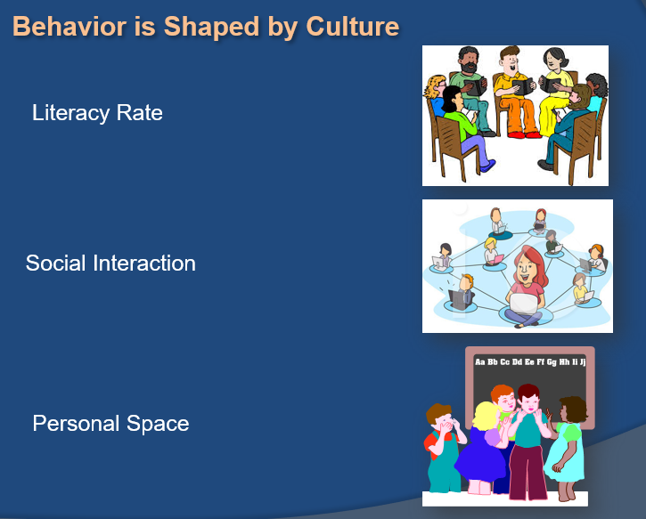
- The more open and diverse a culture is, the greater the chances for self-expression and personal development.
Psychology and Science/
- Psychology is Empirical → It is based on experiments and evidence.
- Knowledge is acquired through observation → Psychologists study behavior and mental processes by observing people.
- Systematic approach to understanding people → It helps in understanding thoughts, emotions, and behavior to solve real-life problems.
Example:
A psychologist observes that students with regular sleep perform better in exams. After research, they suggest a sleep schedule to improve learning.
Branches of Psychology:
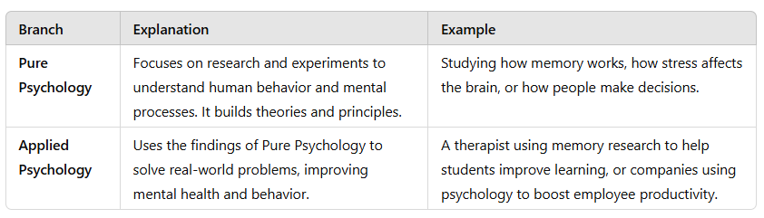
Pure Psychology:
Psychology is the study of how humans and animals behave and why they act in certain ways. It helps understand thoughts, emotions, and actions through research and data.
- Experimental Psychology focuses on studying behavior by collecting data and doing experiments.
- Social Psychology looks at how and why people behave in social situations.
- Abnormal Psychology studies unusual behaviors and mental health issues.
- Developmental Psychology explores how people grow and change over time.
- Comparative Psychology compares the behavior of different animals and humans.
- Physiological Psychology examines how the body reacts to emotions like happiness, stress, and mood changes.
Applied Psychology
Applied psychology uses psychological ideas to solve real-world problems in different areas like mental health, work, education, medicine, and law.
- Clinical Psychology helps people with mental and emotional health issues.
- Industrial Psychology studies how employees behave at work to improve productivity.
- Educational Psychology focuses on how people learn and remember things in school.
- Psychology in Medicine helps doctors use psychology to improve patients' physical and mental health.
- Psychology in Law studies how people understand legal rules and make decisions in court.
Four Primary Goal of Psychology:
Describing and Explaining Behavior
First goal, differentiating between normal, healthy and unhealthy behaviors is the cornerstone of psychology, so it is important that psychologists have a keen sense of observation.
The second goal of psychology, explaining. The attempt to explain behavior based on observation is actually rather difficult due to many factors. For instance, behavior varies among culture and can change over time.
Predicting and Influencing Behavior
Third goal, Psychologists try to determine if a person is likely to make healthy or unhealthy decisions when confronted with certain situations. Most of the time, they will use experiments to make their predictions.
The fourth and the last goals of psychology is to influence behavior. This can be to change unhealthy behavior as well as encourage already existing healthy behavior. There are many methods used to influence behavior such as positive reinforcement or rewarding good behavior.
Rewards (Tangible or External Benefits)
Money – Giving a bonus for hard work
Gifts – Giving a child a toy for good grades
Positive Reinforcement
Encouragement – Motivating someone with kind words
Recognition – Awarding certificates or trophies for achievements
Biological Psychology:
Biological psychology studies how the brain and body influence emotions, memories, and sensory experiences. It includes psychology, biology, physiology, biochemistry, and neuroscience.
- Biological psychology studies the connection between biology and psychological events, like how information moves through the body.
- It also examines body functions, including electrical and chemical processes needed for nervous system communication.
Note: A psychological event refers to any mental or emotional experience influenced by the brain and body. This includes thoughts, emotions, perceptions, and behaviors.
Examples:
- Feeling fear when you see a dangerous animal.
- Remembering a happy memory from childhood.
Behavioral Psychology:
Behavioral Psychology is the study of how people act and react. Behavior means actions we take in response to something. This type of psychology focuses only on actions we can see, not thoughts or feelings.
- Example: Child and Rewards – A child who gets praised for doing homework is more likely to do it again.

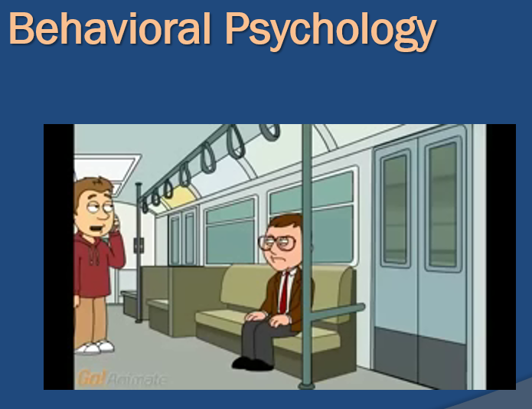
Cognitive psychology
Cognitive psychology is the study of how people think, learn, remember, and solve problems. It focuses on mental processes like attention, memory, perception, decision-making, and language.
- Example: Memory Recall – Remembering your friend's birthday or recalling the name of a song.
Social-Cultural Psychology
Social-Cultural Psychology is about how people are influenced by society and culture. It looks at how our behavior, thoughts, and feelings are shaped by the people around us and the traditions we follow.
For example:
- A person raised in a community that values teamwork may prioritize group success over personal achievements.
- People from different cultures may express emotions differently, such as being more reserved or more expressive.
This also focuses on the fact that our interactions with others in society affect not only our thought process, but also our perception, and the manner in which we make decisions.
Example:
From childhood, we learn from our surroundings, and as we grow older, these influences become even stronger.
Personality Psychology
Personality psychology is a branch of psychology that studies personality and individual differences—what makes us unique.
Key Points:
- It focuses on how our interactions with others shape our thoughts, perceptions, and decision-making.
- Personality development starts in childhood and continues throughout life.
- It explores how personality forms, evolves, and influences behavior.
Experimental Psychology:
Experimental Psychology: A way of studying how the mind works using scientific methods. It helps researchers understand thoughts, feelings, and behaviors through experiments.
- Example: - A memory experiment where researchers show a list of words to participants and then test how many they can remember. This helps understand how memory works and what factors improve or weaken it.
Educational Psychology
Educational Psychology is the study of how people learn in schools. It looks at how teaching methods, school environments, and social interactions affect learning. It also explores how children and teenagers think, feel, and grow as they learn.
- Example: A teacher notices that some students learn better with visual aids, while others prefer hands-on activities. Using educational psychology, the teacher adjusts their teaching style to include pictures, videos, and interactive activities to help all students learn effectively.
Industrial Psychology
It studies how employees and employers think and behave at work. It focuses on workplace environment, employee attitudes, and how these factors affect job performance and satisfaction.
- Example: - A company sees that workers are feeling tired and not working well. An industrial psychologist looks at the workplace, listens to employees, and suggests simple changes like better break times or a nicer office setup to make everyone happier and more productive.
Criminal Psychology:
Criminal psychology is the study of why people commit crimes. It looks at their thoughts, feelings, and actions that lead to criminal behavior.
- Example: - A criminal psychologist studies a thief’s past to understand why they steal. They may find that the person had a tough childhood or was influenced by bad company. This helps in finding ways to prevent future crimes.
Computational Psychology:
Computational psychology combines artificial intelligence and psychology to study how the human mind works using computer models. It helps in understanding thinking, decision-making, and behavior through simulations and algorithms.
- Example: A computational psychologist might create a computer model to predict how people make choices when shopping online.
Importance of Psychology
- Self-Knowledge: Learning is an important part of life, and understanding ourselves is a key part of that learning.
- Learning About Others: Psychology not only helps us understand ourselves but also helps us learn about other people.
- Solving Important Problems: Psychological theories and research can help us find solutions to real-life problems.
Development of Psychology
Human Development is the process of growing and changing throughout life, from birth to old age.
- It studies how and why people change over time.
- It includes physical growth, emotions, thinking abilities, social skills, and personality.
- Example: A baby learning to walk, a child developing friendships, or an adult gaining new skills at work.
Research Method in Psychology
What is Research Method?
A systematic plan to conduct research is called a research methodology.
Types:
- Descriptive Research Method
- Correlational Research Method
- Experimental Research Method
Descriptive Research Method:
This method is used to describe a situation, behavior, or characteristic without changing or influencing anything. We simply further trying to explore and already existing phenomenon.
Example
A researcher asks college students about their sleep habits and records the answers without changing anything. This helps understand sleep patterns.
Methods
- Observational Research/Naturalistic
- Surveys
- Case Studies

Observational Research Method
It means watching and listening to how people behave in a place like a classroom or lab without asking questions or changing anything. It only records what happens without explaining why.
Types:
There are two types of observational research method
- Observation without intervention
- Observation with intervention
Observation without intervention/ Naturalistic
This means watching people or events in their natural setting without interfering. The observer does not change anything, just takes notes or uses audio/video recording.
- Example: Watching kids play in a park from a distance or observing how people behave at work without interrupting.
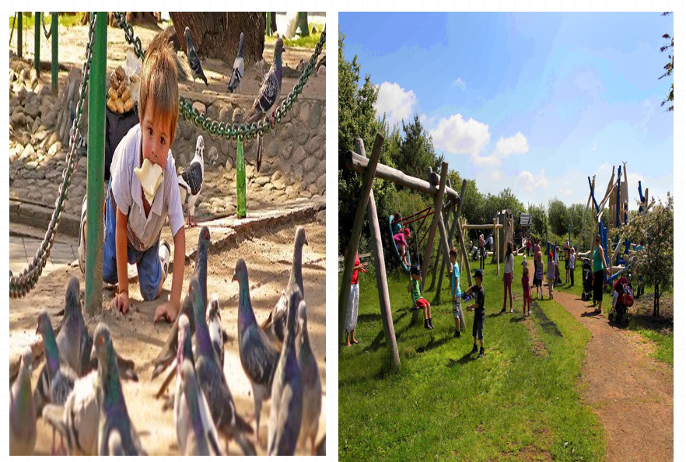
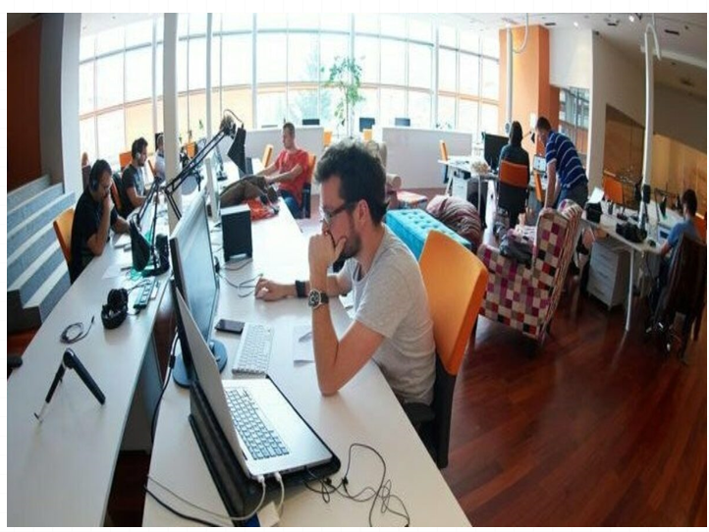
Observation with intervention
Observation with intervention (Participant Observation) means the researcher joins the group and takes part in activities while observing people.
- Example: A teacher joins students in a classroom to observe their behavior while also teaching.
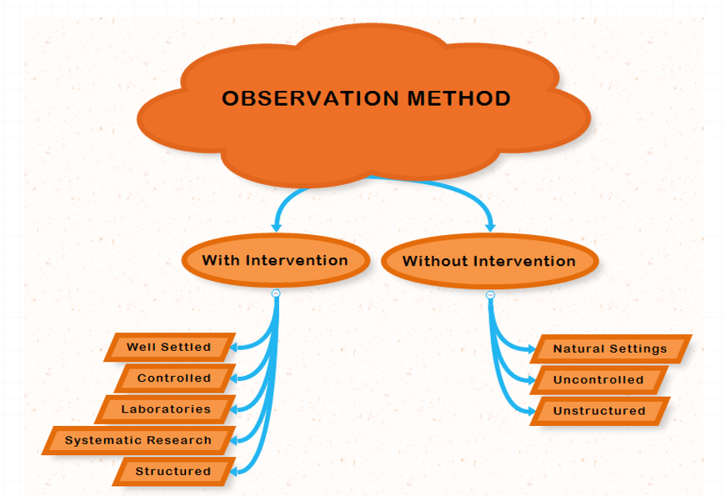
Survey Method:
A method where a sample of people represents a larger population and answers questions about their behavior, thoughts, or attitudes.
Use Cases
- When quick information is needed (e.g., opinion polls).
- When data is needed from a large population (e.g., population census).
Surveys are more suitable when goals of study are to find out about public opinion, attitude, likes/dislikes

Sources
- Questionnaires
- Interviews
- Online
- Telephonic
Components
- Population: The people who are the focus of research
- Sample: A part of population that represents the whole
- Questionnaires – A set of written questions given to subjects to collect data.
- Interviews – A face-to-face or verbal questioning process conducted by a researcher.
Case Study
- An in-depth intensive investigation of an individual or small group of people
- Researcher talks to participants in order to learn about their opinions, attitudes, preferences, likes, dislikes to find out the causes
- Used as a source of data collection in surveys but also used otherwise as well
Correlational Method
This method is used to find a relationship between two things but does not prove that one causes the other. It only shows if they are connected.

Example
The more time students spend studying, the higher their grades tend to be. However, studying does not guarantee higher grades, as other factors like sleep and teaching quality also play a role
Types
- Positive correlation
- Negative correlation
- Zero correlation
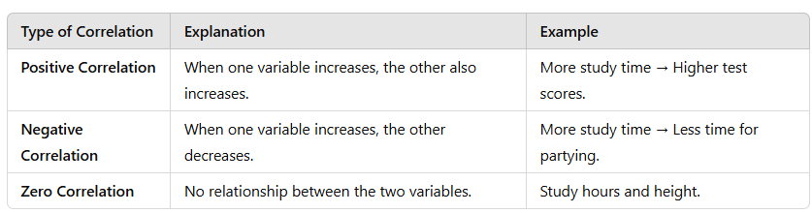
Experimental Research Method:
This method is used to find out if one thing causes another by changing one factor (independent variable) and measuring its effect on another (dependent variable). It includes a control group (which gets no change) and an experimental group (which gets change).
Example:
A teacher gives one group of student’s energy drinks before a test (experimental group) and the other group gets water (control group). Then, she compares their test scores to see if the energy drink helped improve performance.

Components
- Experiment
- Control
- Variables
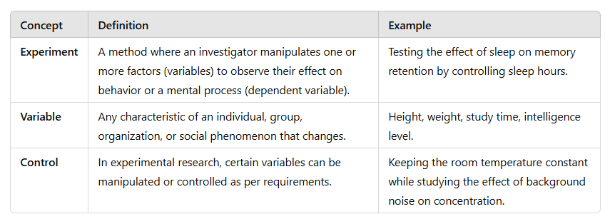
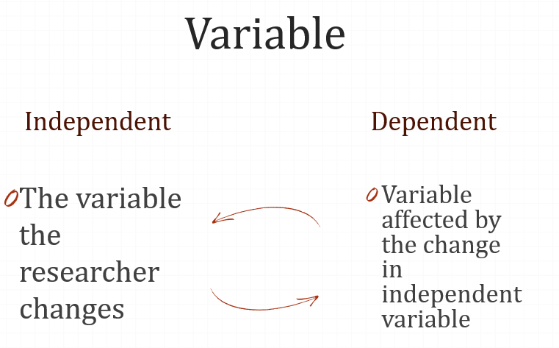

Learning
Learning is often defined as a relatively lasting change in behavior that is the result of experience. learning is the most hopeful of the fields of psychology.
Example:
A child touches a hot stove and gets burned. After that, they avoid touching hot objects. This change in behavior (avoiding heat) is due to learning from experience.
Behaviorism
Behaviorism, founded by John B. Watson, is a school of psychology that focuses only on actions that can be observed and measured. It does not study thoughts or emotions because they are internal and cannot be seen. Instead, behaviorism looks at how people act and respond to different situations.
Example:
For example, if a student studies hard and gets good grades, behaviorists would focus on the study habits rather than the student's thoughts or feelings.
Types of Learning
- Classical Conditioning
- Operant Conditioning
- Cognitive Learning
- Observational Learning

Neutral Stimulus
A stimulus that, before conditioning, does not trigger any specific response.
Example:
A bell ringing before being associated with food does not cause salivation in a dog.
Unconditioned Stimulus
A stimulus that naturally triggers a response without any prior learning.
Example
The smell of food naturally causes a dog to salivate.
Unconditioned Response
A natural and automatic reaction that occurs in response to an unconditioned stimulus without the need for learning.
Example
Salivating when smelling food is a natural response.
Key difference: Unconditioned Stimulus causes the reaction, while Unconditioned Response is the reaction.
Conditioned Stimulus (CS)
A previously neutral stimulus that, after being repeatedly paired with an unconditioned stimulus, starts triggering a response.
Example
After repeated pairing with food, the sound of a bell alone causes the dog to salivate.
Conditioned Response (CR)
A learned response that occurs when a previously neutral stimulus (NS) becomes associated with an unconditioned stimulus (US).
Example
A dog salivates when hearing a bell, even if no food is present. Initially, the bell was neutral, but after being repeatedly paired with food, the dog learned to associate it with food. Now, the bell alone causes salivation, making it a conditioned response.
Classical Conditioning
Classical conditioning is a type of learning where a person or animal starts reacting to something new because it gets linked to something they already react to.
Example:
At first, a bell (neutral stimulus) means nothing to a dog. But if you ring the bell every time before feeding the dog, the dog will start linking the bell to food. Eventually, the dog will salivate just by hearing the bell, even if there is no food.
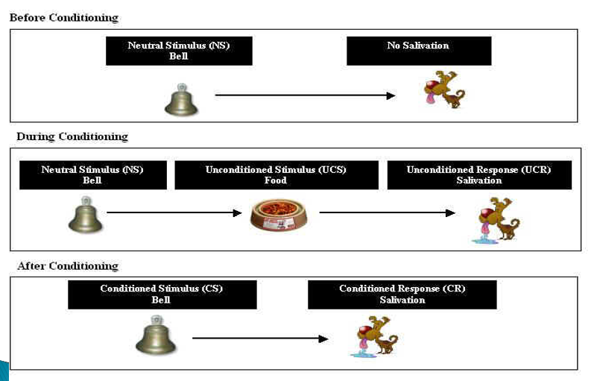
Example In real life
For Example - "fear of bridges “....
A person may develop a fear of bridges through classical conditioning like this:
- Unconditioned Stimulus (US) → A scary experience (e.g., getting stuck on a high bridge during a storm).
- Unconditioned Response (UR) → Feeling terrified during that experience.
- Neutral Stimulus (NS) → The bridge itself (before the scary event, the bridge was neutral).
- Conditioning Process → The person now associates the fear they felt with bridges in general.
- Conditioned Stimulus (CS) → Now, just seeing a bridge or thinking about crossing one triggers fear.
- Conditioned Response (CR) → The person feels anxious or scared whenever they approach a bridge.
Operant Conditioning
Operant conditioning is a way of learning where behaviors are shaped by rewards or punishments. If an action leads to a good outcome, it is more likely to be repeated. If it leads to a bad outcome, it is less likely to happen again. In this learning we are a sought of conditioned base on consequences.
Example:
- If a child gets candy for doing homework, they are more likely to do it again (reward).
- If a child is scolded for shouting, they are less likely to shout again (punishment).
Skinner Experiment
Skinner wanted to study how animals learn in a controlled environment. He created the "Skinner Box," a special chamber with a lever and a food dispenser.
In his experiment, a hungry rat was placed in the box. At first, the rat moved around randomly. By chance, it pressed the lever, and food appeared. The rat did not immediately understand the connection, but after pressing the lever multiple times, it learned that pressing the lever leads to food.
Skinner measured learning by counting how many times the rat pressed the lever within a certain time. This is called the "rate of response."
Skinner’s experiment is an example of operant learning because the rat’s behavior (pressing the lever) is shaped by its consequences (getting food).
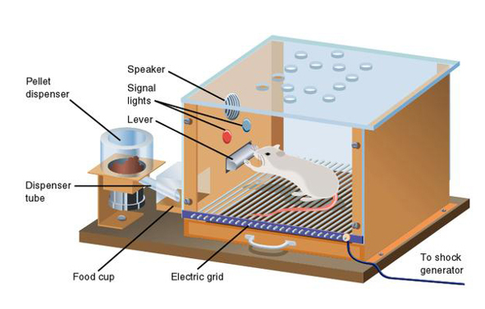
Cognitive Learning
Cognitive learning is how we learn by thinking and understanding. It happens when we gain knowledge through listening, watching, touching, or experiencing things around us.
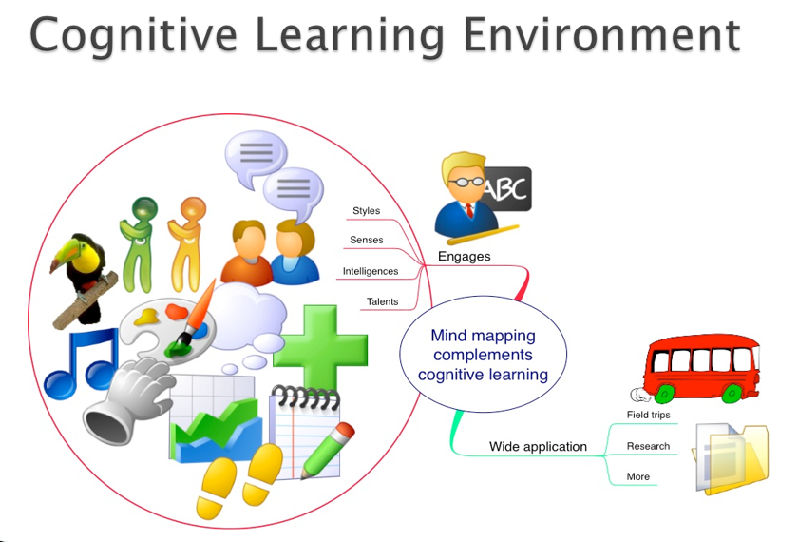
Continue…
Cognitive learning is a strong way of gaining knowledge. It’s more than just copying others—it involves thinking, understanding, and processing information in our minds. It helps us create mental images of objects and events and allows us to organize and use information in different ways.
Real life Example:
A real-life example of cognitive learning is learning to drive a car. At first, a learner doesn’t just memorize steps—they observe how others drive, understand traffic rules, and mentally process how to control the vehicle. With practice, they develop problem-solving skills, like deciding when to brake or change lanes, making driving an automatic and efficient process over time.
Latent Learning (Hidden Learning)
Latent learning happens when we learn something but don’t show it right away. It only becomes useful when we need it.
Example
A student walks around campus daily but never thinks about nearby coffee shops. One day, they want coffee and suddenly remember a new shop they had seen before.
E.C. Tolman’s Idea: He believed that people and animals create mental maps of their surroundings, which they use when needed.
Observational Learning (Learning by Watching)
First introduced by Albert Bandura, observational learning happens when we learn new behaviors by watching and copying others. It is also called vicarious learning, modeling, or social learning.
Example
Example of observational learning is when a teenager learns how to cook by watching their parents in the kitchen. They observe the steps, remember them, and later try cooking the same dish themselves.

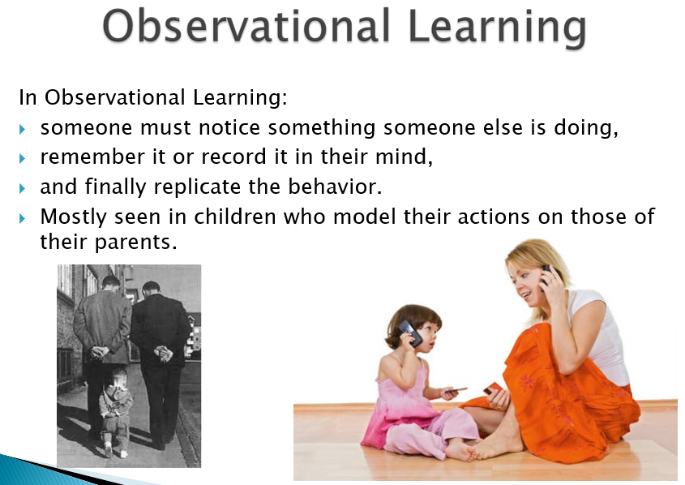
Observational Learning (Modeling) - Simple Explanation
Observational learning is limited by:
- Intelligence level – The smarter a person is, the better they learn by watching.
- Ability to copy – Some people can imitate actions better than others.
This type of learning is also called modeling, which has two main parts:
- Observation – Watching someone do an action.
- Imitation – Trying to copy that action.
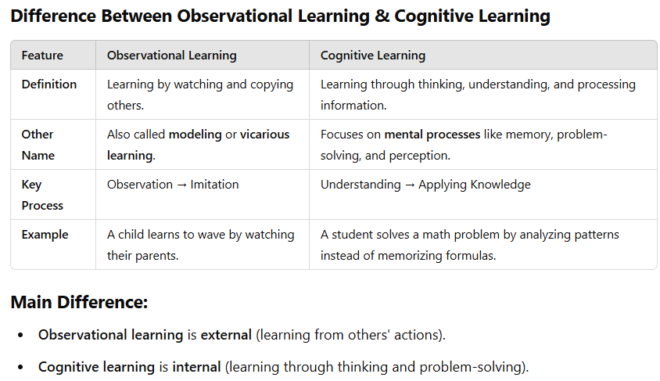
The Modeling Process
- Attention – You must focus on what the person is doing to learn from them. Distractions can make learning harder.
- Retention – You need to remember what you observed so you can use it later.
- Reproduction – After watching and remembering, you try to copy the behavior.
- Motivation – You need a reason to imitate the behavior. If there’s no interest or reward, you might not copy it.
Example: A child watches their older sibling ride a bicycle (Attention), remembers how they balance (Retention), tries to ride on their own (Reproduction), and keeps practicing because they want to have fun (Motivation).
Bobo Doll Experiment (Bandura's Study on Observational Learning)
Albert Bandura conducted an experiment to show how children learn through observation and imitation.
What Happened?
- Watching the Model – Children watched a video of a man aggressively attacking a Bobo doll (a large plastic clown). He hit it, punched it, kicked it, and threw things at it.
- Frustration – After watching the video, the children were placed in a room with attractive toys but were not allowed to touch them, which made them frustrated.
- Imitation – They were then taken to another room with Bobo dolls and the same toys from the video. Many children copied the aggressive behavior they had seen, hitting and kicking the doll just like the man in the video.
Conclusion:
This experiment showed that children learn and imitate behaviors just by watching others, proving the power of observational learning and modeling.
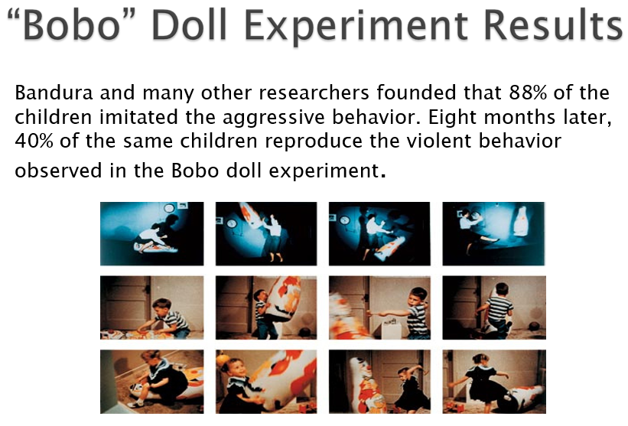

Cognition
Cognition refers to all the mental activities that help us understand and interact with the world. It includes processes like perception (how we see and interpret things), thinking, problem-solving, memory (how we store and recall information), language (how we speak and understand others), and attention (what we focus on). In simple terms, cognition is the way our brain takes in information, makes sense of it, and helps us respond to different situations. It's everything our mind does when we try to learn, understand, remember, or solve problems in everyday life.
Example
For example, when solving a math problem, you first read and understand the question (perception), then recall formulas or rules (memory), focus on each step (attention), and apply logic to find the solution (thinking and problem-solving) — all of these are parts of cognition.
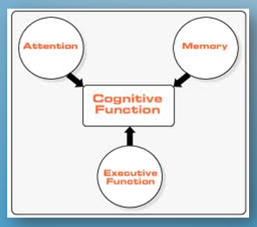

Continue…
- Thinking: Helps us process and analyze information, like solving a puzzle by figuring out the pattern.
- Knowing: Means having understanding or awareness, such as recognizing that water boils at 100°C.
- Remembering: Helps us bring back past information, like recalling your friend's birthday.
- Communicating: Lets us share thoughts and ideas with others, like telling someone how to bake a cake.

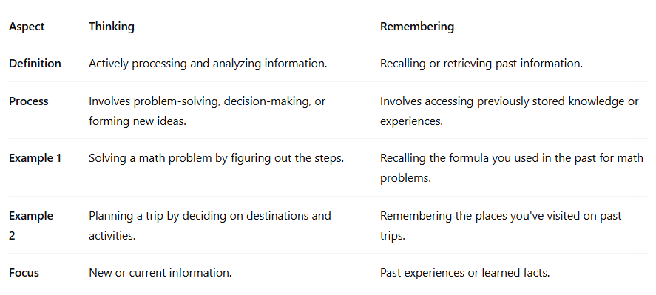
Psychology and Cognition
- Relationship between Thinking and Behavior: How people think about themselves can affect how they act. For example, Carol Dweck’s Mindset theory shows that if someone believes they can improve (a growth mindset), they are more likely to try harder and succeed. On the other hand, if they believe their abilities are fixed (a fixed mindset), they may avoid challenges.
- Stereotyping: This refers to having fixed ideas or assumptions about other people, often without knowing them well. For instance, thinking that all athletes aren't good at school.
- Cognition is about how we know or understand things. It also refers to how groups of people share and develop ideas together. For example, a group might work together to find a solution to a problem, and over time, everyone in the group starts to understand and use that solution as common knowledge.
Continue…
- Cognitive Approach: Imagine someone feels nervous before a presentation. The cognitive approach would focus on how their thoughts (e.g., "I'm going to fail") cause their anxiety and affect their behavior. It would look for patterns in how everyone thinks in these situations and try to find general rules about how thoughts influence behavior.
- Humanist Approach: The humanist approach would focus on the individual's unique experience. It would consider that some people might be nervous before a presentation because of past experiences, personal values, or how they view themselves. It believes everyone has their own reasons for feeling and acting a certain way.
- Biological Approach: The biological approach might look at how a person's brain chemistry or genetics influences their nervousness. For example, they might explore how stress hormones affect behavior or if the person has a genetic predisposition to anxiety.

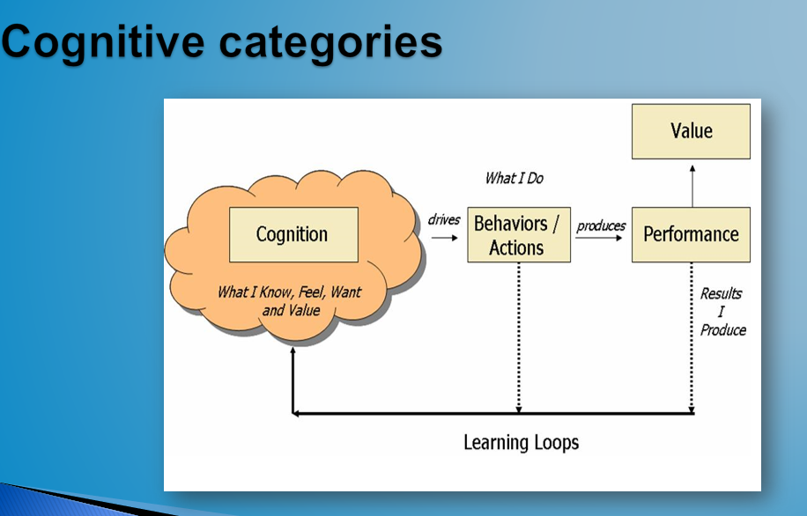
Cognitive categories
- Processing Speed
- Auditory Processing
- Visual Processing
- Long-Term Memory
- Short-Term Memory
- Logic and Reasoning
- Attention Skills
Processing Speed
Processing Speed refers to how quickly your brain can understand and react to information. When your brain processes information faster, it helps you think and learn more efficiently.
As people get older, their processing speed tends to slow down, which can affect their ability to perform tasks that require quick thinking. However, if you regularly challenge your brain and practice mental exercises, you may be able to slow down this decline and maintain your cognitive abilities.
Example: A younger person might quickly solve a math problem in their head, while an older person may take a bit longer. But if the older person practices mental exercises, they might improve their speed over time.
Auditory Processing
Auditory Processing means how well your brain understands and works with sounds. It helps you hear the small sounds in words and put them together. This skill is very important for talking, reading, and spelling. If you can hear and tell the difference between sounds, it’s easier to learn words.
Example: To read the word “dog,” you need to hear the sounds d, o, and g, and then put them together. If your brain struggles with this, reading and spelling can be hard.
Visual Processing
Visual Processing means how well your brain understands and makes sense of what you see. It helps you recognize pictures, shapes, letters, and patterns. This skill is very important for many everyday tasks like reading, remembering faces, walking, driving, or playing sports.
Example: When you see the word "tree," your brain quickly sees the letters, understands the word, and connects it to the image of a tree. This is visual processing at work.
Logic and Reasoning
Fluid Reasoning is the ability to think logically and solve problems using new or unfamiliar information. It helps you understand patterns, plan ahead, and make good decisions.
There are two main types of reasoning:
- Deductive Reasoning: Starts with a general rule and uses it to figure out something specific.
Example: All birds have wings. A sparrow is a bird, so it must have wings.
- Inductive Reasoning: Looks at specific examples to come up with a general rule.
Example: You see that the sun rises every morning, so you think it will rise again tomorrow.
Logic and reasoning are important for decision-making, learning, and solving everyday problems.
Attention Skills
Attention Skills are how well you can focus and manage your attention. There are three main types:
- Sustained Attention: Staying focused on one task for a long time.
Example: Reading a book for 30 minutes without losing focus.
- Selective Attention: Focusing on one thing while ignoring distractions.
Example: Listening to your teacher while other students are talking.
- Divided Attention: Doing two or more things at the same time.
Example: Talking on the phone while cooking dinner.
These skills help us stay on task, avoid distractions, and handle multiple things at once.
Sensation
Sensation is the process where our senses (like seeing, hearing, touching, tasting, and smelling) detect things around us and send it to the brain.
Perception
The senses send this information to the brain. At this stage, the brain has received the information, but it hasn’t figured out what it means yet. That next step—understanding or giving meaning to what we sense—is called perception.
Example: Hearing a Siren
Sensation:
- You hear a loud sound with your ears. Your ears pick up the sound waves—this is the stimulus. The sound travels to your brain.
- This is sensation—your ears detecting the sound.
Perception:
- Your brain recognizes that the sound is a police siren and understands that a police car is nearby.
- This is perception—your brain giving meaning to the sound.

Stimulus:
A stimulus is anything that causes your body to react. It can be something you see, hear, touch, smell, or taste.
Simple Examples:
- A bright light shining in your eyes (stimulus) → You blink (reaction).
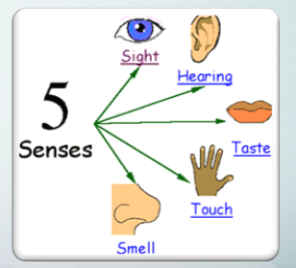
Sensory Receptors
These are special cells in our sense organs (like eyes, ears, nose, skin, tongue). They notice things like light, sound, smell, and touch.
They turn these things into signals that our brain can understand.
Example:
Your eyes have receptors that detect light. When you look at a bright light, those receptors notice it and send a message to your brain saying, "It's bright!"

Transduction
This is the process where sensory receptors change the physical information (like light or sound) into neural impulses—which are signals the brain can understand.
Neural Impulse
A neural impulse is like an electrical message that travels along nerves to the brain or body.
Example:
When you smell something, your nose receptors detect the scent. Then, they change it into a neural impulse and send it to your brain, which tells you, "This is the smell of flowers!"
Effectors
Effectors are body parts (like muscles or glands) that respond to these messages.
Example:
If you touch something hot, the skin receptors send a neural impulse to your brain. Your brain quickly sends a message to your hand muscles (effectors) to pull away.
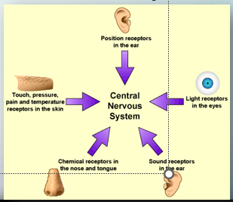
How Sensation occurs?
- Sensory organs absorb energy from a physical stimulus in the environment.
- Sensory receptors convert this energy into neural impulses (electro-chemical signal that is sent from Neurons (nerve cells that send message to body) and send them to the brain
Five Senses
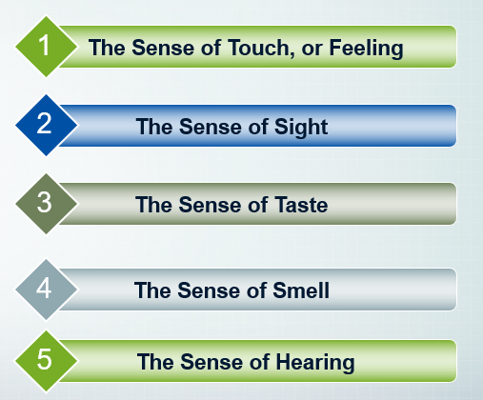
Sense of Touch (or feeling)
Touch is one of our basic senses. It works through special nerves found in our skin and inside our body. These nerves send messages to the brain when something touches us or when something changes inside our body.
- Develop with the passage of time
- Prior Knowledge
Example:
When you touch a hot cup, nerves in your fingers feel the heat and send a message to your brain.
When you press a soft pillow, you can feel its shape and softness because of these nerves.
With the sense of touch, we can feel:
- Size (big or small)
- Shape (round or square)
- Texture (rough or smooth)
- Hardness (hard or soft)
- Elasticity (stretchy or not)
Q: It is not compulsory that how abrupt we will react our body will also produce response too quickly?
Ans: It is because of the Prior Knowledge and Due to the spinal cord that we will able to response quickly
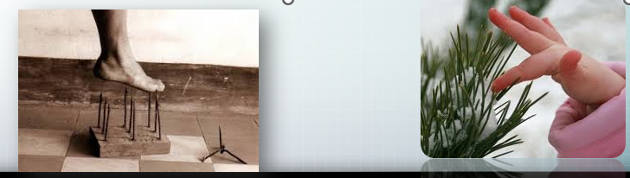
The Sense of Sight
We see things with our eyes by using light. Our eyes don’t need to touch anything to see it. Instead, light comes from objects and enters our eyes. The eyes catch this light and send messages to the brain. The brain then tells us what we are seeing—like the color, shape, or brightness.
Example:
When you look at the sun, your eyes feel the bright light. When you look at a red apple, your eyes see the red color because of the light coming from it.
Continue…
The human eye helps us see and is the main organ for the sense of sight. It helps us understand more about the world around us than any of our other senses. We use our eyes in almost everything we do—like reading, writing, watching TV, driving, working, and much more.
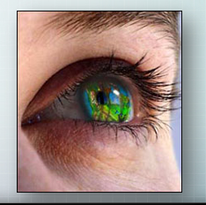

Sense of Taste
The sense of taste helps us know the flavor of things we eat or drink. It works through tiny parts on our tongue called taste buds. When food touches the tongue, the taste buds get excited by the chemicals in the food. Then, they send messages through the nerves to the brain to tell us what it tastes like.
Scientists say there are five main tastes:
- Sweet (like sugar)
- Sour (like lemon)
- Bitter (like strong coffee or medicine)
- Salty (like chips)
- Hot or Spicy (like chili or pepper)
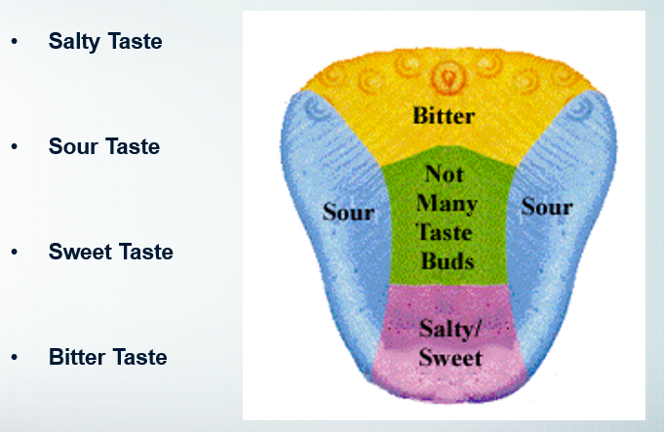
Sense of Smell
The sense of smell is similar to taste because it also detects chemicals. But the big difference is that smell can sense things from much farther away than taste can. While taste works when something is in your mouth, smell can tell you about things even if they’re far from you!
Example of Smell:
Imagine you're walking outside and you suddenly smell freshly baked bread. Even though the bakery might be far away, your nose can detect the scent in the air. That's the sense of smell at work, detecting chemicals from the bread in the air and sending the signal to your brain.

Sense of Hearing
The sense of hearing helps us listen to sounds. It works through special nerves inside the ear.
When sound waves (vibrations in the air) reach the eardrum, it vibrates. These vibrations get stronger, and then the nerves in the ear pick up the signal and send it to the brain.
We hear sounds in different ways:
- Pitch: Is the sound high (like a whistle) or low (like a drum)?
- Intensity: Is the sound loud or soft?
- Quality: Is the sound clear or unclear?
- Harmony: Do the sounds blend well together (like music)?
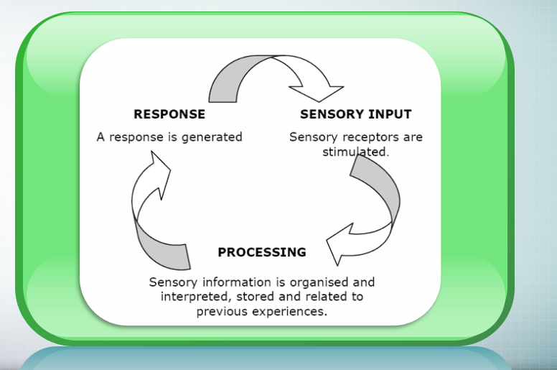
Sensory Processing Continue…
We know about the senses of sight, hearing, taste, and smell, but there are also three other important sensory systems that help us in powerful ways. These systems help us:
- Feel safe and secure
- Focus and pay attention
- Move easily without fear
- Use our bodies automatically to do everyday tasks, like walking, writing, or getting dressed.
These extra systems are important for us to understand and react to the world around us without thinking too much about it.
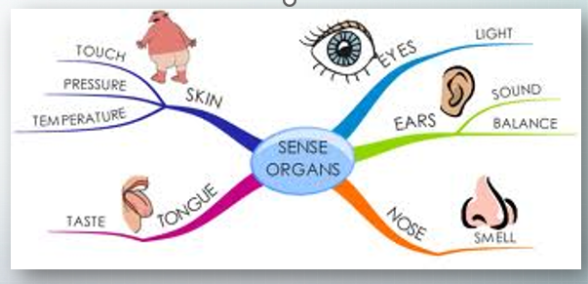
What is Abnormal Behavior?
Abnormal behavior refers to actions, thoughts, or feelings that are unusual, unexpected, or outside the norms of society. These behaviors often disturb the person or those around them, and can interfere with their ability to live a normal life.
According to the “harmful dysfunction” model, behavior is considered abnormal if it meets certain criteria. It must be:
Atypical – It’s very rare or unusual.
Example: A person laughs at a funeral.
Disturbing – It upsets the person or others.
Example: Screaming loudly in public for no reason.
Maladaptive – It stops a person from living normally.
Example: Being too scared to leave the house.
Unjustifiable – There’s no clear reason for it.
Example: Feeling extreme fear when nothing is wrong.
Example
Avoiding all social contact without a clear reason: If a person completely isolates themselves, avoids family and friends, and refuses to speak to others, this behavior is abnormal. It may be a personal choice at first, but if it lasts long and affects their well-being, it might point to something more serious.
How is it connected to Psychological Disorder?
- Abnormal behavior can lead to a psychological disorder if it becomes serious and ongoing.
What is Psychologically Abnormal?
Psychological abnormality refers to thoughts, emotions, or behaviors that are unusual and can cause problems in daily life. Psychologists often use the Four Ds to understand whether something is abnormal.
Four Ds
- Deviance\Atypical
- Distress
- Dysfunction
- Danger

Example
For example, feeling sad after being rejected is normal. But if that sadness turns into deep depression—like losing interest in everything, not sleeping or eating, and thinking about suicide—it may be a sign of a disorder.
However, not everything that is rare is a disorder. Red hair, for example, is rare but not a mental disorder. It’s just an uncommon trait.
Deviance
Doing something that breaks the rules or expectations of a society. It means acting differently from what people think is normal or proper.
Example:
- Hearing voices when no one is there.
Norms
- The rules a society has about how people should behave.
- Some rules are spoken clearly (explicit), and some are just understood (implicit).
Culture
- The shared way of life for a group of people.
- Includes their history, values, beliefs, habits, skills, technology, and arts.
- Culture shapes what people think is normal or acceptable.
What is seen as right or wrong (valuation) changes from one culture to another. So, something that is "deviant" in one culture might be normal in another.
Explicit Rules and Implicit Rules
Explicit Rules | Implicit Rules
Definition  - These are clear and openly stated rules.  - Everyone knows about them because they are written down or told clearly. | Definition  - These are unspoken or hidden rules.  - People just understand them by watching or learning from others.
Example:  - Traffic laws like “Stop at a red light.”  - School rules like “No cheating on exams.” | Example:  - Saying “please” and “thank you” to be polite.  - Not interrupting when someone else is talking.

Distress
- When a person’s thoughts, feelings, or behaviors cause them pain, worry, or discomfort inside—either mentally or physically.
- If these feelings make life hard or upsetting, then the behavior can be called abnormal.
Example:
- Feeling very sad or anxious all the time without knowing why.
- Getting upset so much that it’s hard to enjoy anything.
Dysfunctional
- When a person’s behavior gets in the way of normal daily life — like work, school, relationships, or self-care.
- It means they can’t do what they normally should, and this causes serious problems.
Key Points:
- Inability or loss of ability to perform usual tasks or roles.
- Compare how the person is performing with:
  - What the role requires (e.g., job duties, school responsibilities).
  - What the person is capable of doing (their true potential).
Example:
A student with severe anxiety may skip school often, even though they were once a top performer. Their current behavior is not matching what school requires, or what they could do before.
Dangerous – When behavior can cause harm
- This means the person’s behavior is unsafe and could hurt themselves or others.
- It often happens because of strong emotions or serious mental health issues.
Examples:
- A person having thoughts of suicide (danger to self).
- Someone becoming violent or aggressive toward others (danger to others).
What is Psychopathology?
Psychopathology i the study of mental disorders. It looks at:
- The symptoms (what the person feels or does)
- The causes (called etiology)
- The treatments (how the disorder can be managed or cured)
The term also refers to the actual signs or experiences of the disorder.
How Do We Know if Something is Abnormal?
Not every strange or intense feeling means a person has a disorder. For example, feeling nervous when talking to someone you are attached with or feeling homesick (feeling sad or upset because you are away from home and missing your family) in your first year of college are normal experiences. They are common and usually not signs of a disorder.
Mental health professionals must carefully decide whether a person's thoughts or behaviors truly show a disorder or if they are just different or temporary reactions to life situations.
Early Theories – What people used to believe about abnormal behavior
- In ancient times, people thought abnormal behavior (like strange thoughts or actions) was caused by evil spirits inside a person.
- They believed these spirits needed to be let out of the body.
Trephining
- To do this, they used a method called trephining, where they drilled a hole in the skull to release the evil spirit.
- This was a common practice long ago, even though it was dangerous and not based on science.
Models of Abnormality
Biological / Biomedical Approach
- Mental health problems are like illnesses:
This model says that mental disorders are real illnesses, just like a cold or a broken bone — but they affect the brain and nervous system.
- Problems come from the body:
Strange behavior, thoughts, or feelings happen because something is wrong in the body — like brain chemicals not being balanced, or problems in the brain's structure.
- To understand the problem, we study the brain:
If someone has a mental illness, doctors look at what went wrong in their brain or body to help treat it — usually with medicine or medical tests.
Possible Causes of Abnormal Behavior
- Biochemistry (Brain Chemicals and Hormones):
Sometimes, the brain has too much or too little of certain chemicals (called neurotransmitters) or hormones.
This imbalance can make the brain not work properly, which may lead to mental health problems.

Example
Low levels of serotonin in the brain can cause depression, making someone feel very sad and tired all the time.
- Structural Damage or Brain Problems:
If part of the brain is damaged (from an accident, injury, or illness), or if the brain didn’t form the right way, it can affect how a person thinks, feels, or behaves.
Example:
A person who has a brain injury in the front part of their brain (which controls decision-making and emotions) might start behaving in unusual or risky ways.
Psychodynamic Approach
This idea says that mental problems come from hidden feelings or memories, especially from childhood. These feelings stay deep inside the mind, and the person might not even know they’re there. For example, A person gets very angry at small things but doesn’t understand why. It might be because they were treated unfairly as a child and still carry that pain inside.
Therapy helps bring these hidden feelings into the open so the person can understand and deal with them.
Behavioral Approach
Abnormal behavior is learned:
People behave in strange or unhealthy ways because they learned it from their environment or experiences — not because of illness or something wrong in the brain.
Normal and abnormal behavior are learned the same way:
There is no big difference between normal and abnormal behavior.
Both are learned through the same methods, like:
- Classical Conditioning: Learning by association.
Example: If someone was in a car crash and now feels scared every time they get into a car, they have learned fear through classical conditioning.
- Social Learning: Learning by watching others.
Example: A teenager starts smoking because they see their friends or parents doing it.
- Operant Conditioning: Learning happens because of rewards or punishments.
Example: A student studies hard because they get praise and good grades from their teacher. The reward (praise and grades) makes them want to keep studying hard.
Cognitive Approach
This approach focuses on how people think. It says that negative thoughts can cause mental problems. If someone always thinks in a negative way, it can affect how they feel and act. For example, a student thinks, “I’m stupid” every time they make a small mistake. These thoughts make them feel sad and give up easily.
Therapy helps them change this thought to something better, like “Everyone makes mistakes — I can learn from them.”
Factors in Abnormal Behavior with Examples
- Inaccurate perception:
Example: Thinking someone is angry at you when they’re not.
- Poor reasoning and problem solving:
Example: Believing there’s no way to fix a small mistake and giving up.
- Cognitive-emotion relationship:
Example: Feeling sad because you keep thinking, “I’m not good enough.”
- Thinking is most important:
Example: Therapy focuses on changing your thoughts, not digging into why the thoughts began.
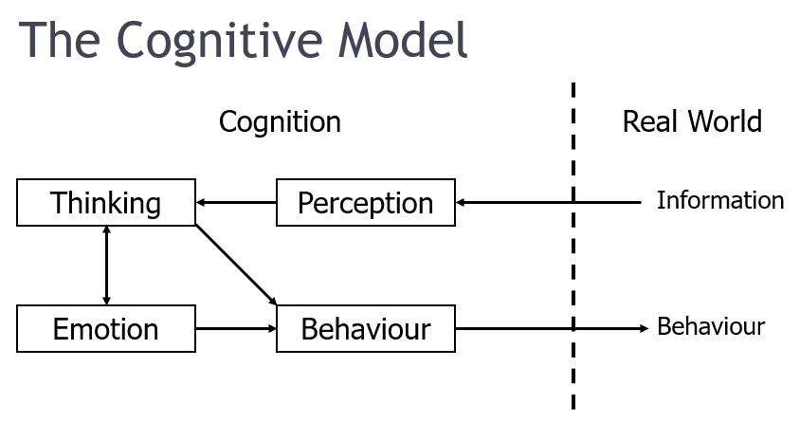

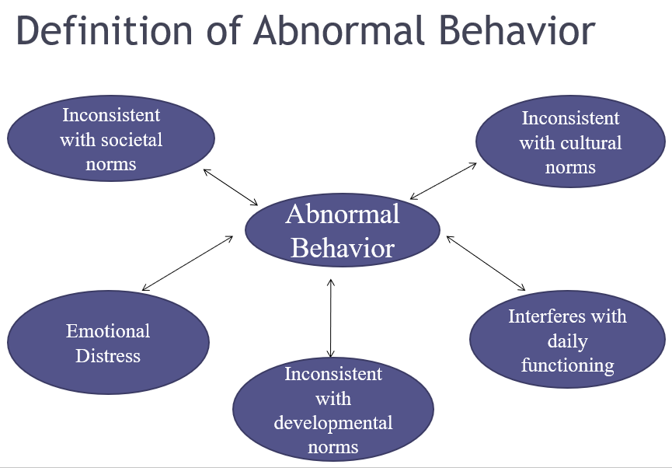
Humanistic Approach
This approach says that mental problems happen when people don’t try to be their best or don’t understand their own feelings. This approach focuses on how people naturally want to grow, be happy, and reach their full potential.
Example:
Someone feels unhappy because they don’t follow their dreams or goals.
Factors in Abnormal Behavior
When someone struggles with mental health, it’s often because they:
1. Not trying to be your best (Failure to reach your potential):
This means not doing what you’re really good at or what you really want to do.
Example: You might feel sad because you never try to follow your dreams or goals.
2. Not knowing your true feelings (Being out of touch with your feelings):
This means not paying attention to how you really feel inside.
Example: You might ignore feeling upset, and because of that, you feel confused or unhappy.
3. People want to grow and be happy:
This means everyone wants to improve and feel good about life.
Example: When people feel accepted and loved by others, they try harder to become better.
4. Everyone can choose and change:
This means people can decide to make their lives better by choosing to change.
Example: Someone decides to ask for help or go to therapy to feel happier.
Socio-Cultural Perspective
This idea says that a person’s behavior and mental health are strongly influenced by the society and culture they live in.
- Society means the community or group of people around you.
- Culture means the beliefs, traditions, and ways of living that a group of people share.
How it can cause disorders:
If the society or culture has problems like:
- Poverty: Living without enough money can make someone feel worried and stressed all the time.
- Discrimination: Being treated unfairly because of your skin color can make you feel sad and anxious.
- Family problems or conflict: Fighting parents can make a child feel scared and upset.
- Social isolation (feeling left out): Feeling left out at school can make a person feel lonely and depressed.
- Pressure to follow strict rules: Having to meet very high expectations can cause someone to feel overwhelmed and stressed.
These problems can make a person feel stressed, lonely, or unhappy. Over time, this can lead to mental health problems like anxiety, depression, or behavior issues.
Example:
A person who faces constant discrimination at school or work might start feeling very sad or anxious because they don’t feel accepted.
Culture and Social Expectations in Mental Disorders
Just because someone acts differently or unusually doesn't always mean they have a psychological disorder. Being atypical alone isn't enough. But if someone's behavior goes against common cultural or social expectations, it might be seen as a possible sign of a disorder.
For example, imagine a woman walking around a subway station in the middle of July wearing a thick winter coat and shouting rude words at strangers. This behavior is very unusual and breaks the normal social rules for how to dress and act in public. Because of this, her actions may be seen as symptoms of a psychological disorder.
Cultural Expectations and Mental Disorders
Cultural expectations play a big role in how behavior is judged. What’s normal in one culture may seem unusual in another, so context matters. For example, smiling at strangers is normal in the U.S. but not in Japan, where being quiet around strangers is common. Eye contact is seen as respectful in Western cultures but can be viewed as rude in some Asian, African, or Latin American cultures. Hearing voices is often seen as a mental illness in the West, but in some cultures, it’s considered a spiritual experience. Cultural norms also change over time—what once seemed normal can later appear strange.
The Myth of Mental Illness
In the 1950s and 1960s, Thomas Szasz argued that mental illness was not a real disease. He believed that society created the idea of mental illness to control people who behave differently. According to Szasz, what we call mental illness is really just a problem in living—people struggling with life, not suffering from a medical condition. He said real diseases involve physical damage or infection, which mental illness usually does not show.
Even though many disagreed with him, Szasz's ideas had a strong impact. His work helped shift the language from "mental illness" to "mental health problems." He also spoke out early against calling homosexuality a disorder and helped promote better rights and personal freedom for people in psychiatric hospitals.
What the APA Says a Psychological Disorder Is
The American Psychiatric Association (APA) also has a definition. According to them, a psychological disorder has these four parts:
- Unusual and troubling thoughts, feelings, or behaviors
These are not just different, but negative and upsetting. For example, someone who constantly washes their hands because of fear of germs shows signs that something is wrong.
- Some kind of inner problem is causing it
The person’s brain or mind may not be working normally. For example, hallucinations (Hallucinations are when a person sees, hears, feels, smells, or tastes things that aren’t really there) in people with schizophrenia (Schizophrenia is a serious mental disorder that affects how a person thinks, feels, and behave) may be due to brain problems.
- It causes real problems in life
If the person’s issue makes them very sad, stressed, or stops them from living a normal life (like working, studying, or having friends), it may be a disorder.
- It’s not just a normal response to something upsetting
Feeling sad after losing a loved one is normal, not a disorder. A disorder means the reaction is much stronger than what’s expected and doesn’t match the situation.
Final Thoughts
There’s no single test or rule that tells us for sure if someone has a disorder. Everyone feels worried or sad sometimes. But if these feelings are too strong, don’t go away, and get in the way of normal life, then it may be a psychological disorder.
Understanding Psychological Disorders
The first step in studying mental health issues is to carefully observe a person's thoughts, feelings, and behaviors. Mental health professionals need to figure out whether what someone is going through is actually a psychological disorder. To do this, they must give a correct diagnosis, meaning they identify and name the disorder based on a list of symptoms.
A correct diagnosis helps:
- Professionals communicate better with each other and with patients.
- Choose the right treatment. To make this possible, a classification system is needed to organize mental disorders in a clear and systematic way.
Classifying Psychological Disorders
What Is the DSM?
In the U.S., mental health professionals use the DSM (Diagnostic and Statistical Manual of Mental Disorders) to understand and diagnose mental illnesses.
The current version, DSM-5, was published in 2013 by the American Psychiatric Association (not the same as the American Psychological Association).
The first DSM came out in 1952, based on a military system. It has been updated many times to improve how disorders are described.
What Does the DSM-5 Contain?
DSM-5 lists many mental disorders like anxiety, depression, and dissociative disorders.
For each disorder, it gives:
- What it looks like
- Symptoms needed for diagnosis
- How common it is
- Risk factors
It also explains comorbidity — when someone has more than one disorder.
Example: Many people with anxiety disorders also suffer from depression.
How the DSM Has Changed Over Time
The DSM has changed a lot:
- Early editions listed homosexuality as a disorder, but it was removed in 1973.
- DSM-I (1952): 106 disorders, 130 pages
- DSM-III (1980): 265 disorders, nearly 900 pages
- DSM-5 (2013): Fewer disorders (237) but better descriptions and focus on culture and gender.
Criticism of the DSM-5
- Labels normal feelings as disorders (called over-pathologizing): For example, Sadness after a loved one’s death might now be called depression.
- It may turn normal grief into a medical disorder, even when someone is just going through a natural loss.
Because of this, some worry that too many people are being called mentally ill. One study showed that almost half of Americans may be diagnosed with a mental disorder at some point.

